NEA Analysis
Useful links.
- https://www.youtube.com/watch?v=gE2gTCwLdFM
- https://www.codingame.com/learn/pathfinding
- https://iopscience.iop.org/article/10.1088/1742-6596/1566/1/012061/pdf
- https://www.youtube.com/watch?v=rbYxbIMOZkE
- https://www.youtube.com/watch?v=W1qvb86YOK0 - IDEAL
- https://www.youtube.com/watch?v=ayRwygd_rQw
- https://www.redblobgames.com/pathfinding/a-star/introduction.html

Art styles.
- https://3d-ace.com/blog/2d-game-art-styles-the-ultimate-guide/
Idea and problem:

The problem is to solve is the inefficiency of safety procedures in small areas with lots of people (For example an office). As there are many people who work there at one time, it is important to plan methods of evacuation that fit each person and work in the favour of the group (ex. Not having too many people going through one door or flight of stairs).

In order to provide a satisfactory product, I will be testing this on my friend who is really interested in safety and computers. He will provide insight into what he finds easy, difficult and / or convoluted. My end user would be a company or group of people who are looking for software for safety (theoretically). This could be any company that owns office buildings or spaces where employees or people work.
Realistically, this is an investigation to see how efficient evacuation procedures could be or how fast you can move a large group of people through a small space using computer algorithms and relevant information about people and spaces. This could be especially interesting when using flow fields for many people. I am excited to see how I can implement this in my NEA.

I aim to make a video-game style application that creates different routes through computer pathfinding for multiple individuals in different situations. I want to do this to explore practical applications of person specific pathfinding in real life (for example, an office building). The final product will ideally have variable settings, a visual environment and other interesting aspects for the user.

What already exists and how does it solve this issue?
To start, there are many people who have created pathfinding applications that could be applied to this situation. For example, in this video a person created a pathfinding algorithm using “flow fields” (I will talk about these later) which is essentially a method within the logic of pathfinding that can improve efficiency. This person utilises a game engine called "unity” to put code, images and other assets together (I will talk about environments later, too). They have solved the issue of pathfinding multiple objects by implementing the aforementioned ideas and grouping them together in a game engine. I aim to do a similar thing in my selected engine but to a lesser extent.

In reference to my idea specifically, I could not find any references online, but many people have achieved the same rough idea so I believe that I will have the resources and skill I need.

Research:

What is a pathfinding algorithm?
A pathfinding algorithm is a method of creating a path from one point to another through iterations. They are a set of rules that can be applied to any situation so that they can be implemented anywhere. These algorithms are used throughout the world for many applications such as traffic routing: robotic research and study, and (most importantly) video games.

What pathfinding algorithms are there?
There are many pathfinding algorithms to explore:
- A* algorithm – This is widely seen as the most efficient and fast algorithm for pathfinding to an objective. It uses something called a heuristic function that enables it to calculate the distance from the destination. It uses this to ignore unnecessary paths and focus on the most direct ones. Once it's found the goal, it can reliably recreate the fastest path from point to point. Whilst this algorithm is useful, it is also extremely complicated to recreate in any program and requires a lot of time and effort.

- Dijkstra's – Calculates every single route through the graph or node tree and selects the route with the lowest “cost”. The cost is determined by summing the weight of the edges along the path. The paths get weights as the algorithm explores and calculates the shortest path. Dijkstra's algorithm is complicated and has some problems with negative edge weights. No to mention it is on the more difficult side of algorithms to implement

- BFS (Breadth-First Search)- A more basic idea of a pathfinding algorithm where, from a starting point, the computer explores the subsequent, adjacent nodes and from each of them explores the adjacent nodes and so on. It utilises a queue system to systematically go through each node in order. This style usually requires extra memory for all nodes it goes to and must keep track of each node before it. It does this because once it reaches its destination, it can recreate the fastest path from all the data that was stored earlier. It struggles with memory management on larger scales and node trees but compared to other algorithms, it can perform extremely well. I enjoyed comparing algorithms on this website.

Out of these three, the one I am interested in is BFS (Breadth-first search). This is not the most efficient, pathfinding algorithm but it is the easiest to implement and has shockingly reliable results. I chose this because logically I can understand it quite easily and from the outside, it looks like it is very doable for my skill level. As mentioned previously, I have tested each algorithm on this website and came to the conclusion that for my project the strength and simplicity of BFS would be perfect.
How does BFS work?
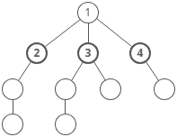
BFS is a basic search / pathfinding algorithm. It works by exploring a graph or a tree systematically. By starting at the source node, BFS essentially “spreads” out into all adjacent nodes and records their position and the node that they came from (this will be useful later). BFS uses a queue system to sort through each node on a level, so nothing is missed. In my implementation, the BFS algorithm will be searching for a specific node that I will call the objective. When the algorithm scrubs through each node at each level, it will eventually land on the objective. To reconstruct the path, the achieving node is traced back through its parents to the beginning where the shortest path is now output. Source.
How does this translate into code?
In python a good way to implement BFS is to use something called “deque” which is a function that adds a “double ended queue”. This only means that for a normal python queue that supports “First in, first out”, deqeue additionally supports “Last in, first out” which makes it more flexible when coding (Things like task scheduling and real-time data processing. Source.

The use of a logical idea called “flow fields” alongside BFS would increase performance for my specific situation where many people in different locations need to end up in one spot.

How do flow fields come into this?
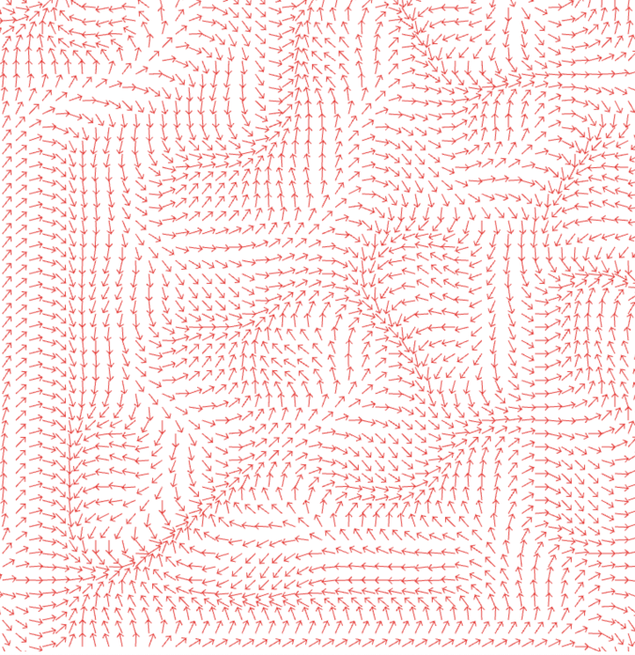
Flow fields are essentially large grids or areas that for every position contain a vector (direction and magnitude) (source) This can be incredibly useful for pathfinding when dealing with many objects or “people” that converge to the same point or destination. Computationally, this would work by calculating the vectors of every grid point in an area so that they point towards the destination. This means that after one calculation, any pathfinding object can use the same map to determine an efficient route to its destination or objective. This obviously only works when one destination is required for multiple starting points. For my implementation of BFS, the computer would already be calculating many paths anyway, so this allows me to record these paths to reuse them.

What environment could I use for all this?

Now that I have decided what algorithm I want to use, I need to settle upon an environment, here are a few I have been considering:
- Pygame – Pygame is a simple game engine that can use media libraries for more graphical games than just a console line. Pygame is great for small games as its language is relatively simple, and high level so it can be learnt and interpreted with relative ease. Looking at the games built with this engine, I can see that they tend to be 2d, pixelated games that are not the most resource efficient.

- Unity – Unity is a massive 3d / 2d game engine that has been used for countless indie and AAA games, it has a wide variety of in built libraries with a huge community and well written documentation, it is not the most resource efficient but has proven to be an extremely useful and competent engine. It uses c# a coding language that I am familiar with, so using this engine would not be “going blind”. Overall unity looks like a great choice, yet in a lot of ways it is a bit “overkill” for the applications I am using it for.

- Godot – Comparatively lightweight than unity and excels in 2d games. It uses GDscript which is allegedly quite easy to learn and is quite powerful. This game engine supports high quality art and high complexity code whilst also having a large community and useful documentation to fall back on. A common negative thing about this engine is the fact that it has less advanced features but, in my case, I do not need those features as I will strive to code what I need.

In conclusion, what environment I will use depends on what final product I need. In my head, I envision an isometric top-down view of an office building, where there are multiple floors and routes to take. You would be able to see each layer and person and potentially even change the environment and people.
In theory this would be perfect for my use, but I am not sure if it is the most realistic – As a backup I could also do a simpler 2d “game” where I can then focus on the pathfinding, which I need to implement in Pygame. For a more complex 3d project, an engine such as Godot may be more suited to my needs as it is more lightweight than unity (allowing me to maximise performance) and uses C++ which I can learn to apply my ideas.
It also comes with native 3d and 2d support. (https://www.youtube.com/watch?v=Lt9YdQ6Ztm4
but of course, everything that I do would be by me (e.g., Using no built-in features) This would allow me to achieve the look I want.

Even though Godot would be perfect for my ideal product, I believe that it might be too complicated and intricate for the time limit I am working with. In order to be realistic I need to manage expectations and factor in my ability. In light of this, I decided to continue with pygame. This means I can use python which I am already quite familiar with and comes with 2d support while also having a large amount of documentation online for debugging. Whilst this is not my first choice, I believe it is for the best.

What other coding ideas would I need?
- Databases – I would like to use databases to store variables about different “People” which I can later use to change the results of my pathfinding. The database will be a collection of “stats”.
- OOP – Object oriented programming will need to be used when I am dealing with instances of people that I am copying repeatedly – this is coupled with instantiation which is where you can “copy” a person in different aspects of speed, age, etc.)

What am I aiming for with my prototype?
I am aiming to have a representation of BFS working in pygame with multiple points as an example of what could be achieved. This will hopefully be done using flow fields. My prototype will have a 2d grid with points that I can move around, which will then have a path calculated between them.

Here is an example of how I imagine a pathfinding evacuation procedure would look:
Requirements:
For this project, I have compiled a list of things that I will need to maximise productivity and performance.
- Computer running windows 11 – I will need a computer running windows so that I can download the necessary software (Such as visual studio and pygame)
- Laptop – A laptop will allow me to take my work out and about meaning that during school hours I can continue working on this project
- Database of info for coding and researching Pygame and visual studio – I will need this for debugging and learning
- Reliable internet connection – I will need this for inline documentation and uploading files to the NEA word file.
- A buddy – I will need this for testing
To meet these requirements, I have a laptop loaded with windows 11 and all the software I need to complete this project. (I also have a buddy).

Design: link

System decomposition:
My final product will be a visualization of pathfinding and edge weights through the gaze of an office building on fire. In order to achieve this, there are multiple aspects I must make.
This will have elements of a game so I will need to build a main menu where I am user can view, edit and submit different settings and parameters, I'll talk more about this later.
Secondly, I need to be able to draw and interact with a game board that resembles an office floor – this will be an amalgamation of a virtual board that the computer can interpret and a board that pygame can render for the user.
Additionally, I must create a class system for the “people” in the office where I can introduce traits that will affect their survival. These people will need to be registered on a virtual board and easily accessible by the computer. I can see that handling different objects will get very confusing as I will struggle to remember what each line of code does so It's important for me to label and comment variables and lines accordingly to avoid this issue.
As mentioned above, I will have a “fire” that will procedurally spread through the office building. This should be relatively simple so I'm not too worried about it, If I have more time, I can implement different materials that take longer to burn.
System composition and structure
IPSO Chart:
Inputs | Processes | Storage | Outputs
- NPC Locations  - NPC Stats and features  - Target point  - When to go and stop | - Distances from point  - Edge weights  - Time left  - NPC speeds and where they go next | - NPC stats – stored in txt files  - Other information stored in txt file  - At the end, what happened? | - Visual representation of what is happening in context  - Statistics of what happened and why
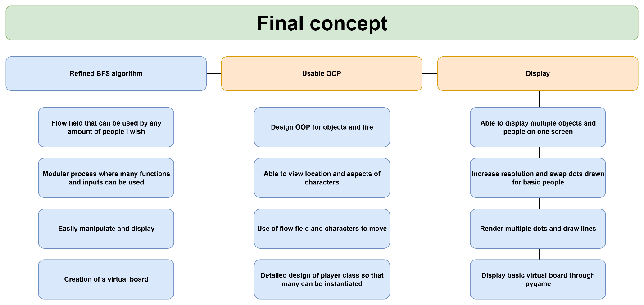Above is a stepwise refinement representation of the steps to building a final product. It incorporates 3 vital aspects and how they can be achieved in loose steps.

UML overview:

Class diagram:
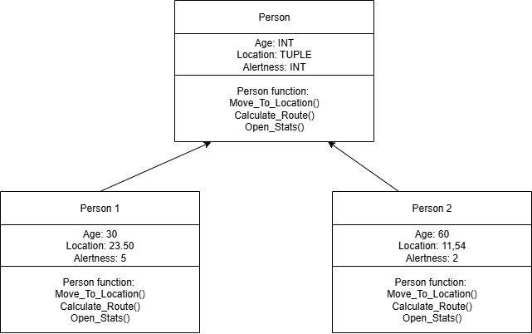
This diagram shows how I aim to instantiate different people with different characteristics that can affect the outcome of the pathfinding – This can be done using OOP to add a good level of complexity to the program.
I am going to use a cell class to categories each cell in the board; they will each be stored in a list. This diagram shows how I aim to add multiple attributes like position, weight, etc... And multiple functions to reference those attributes so that each cell can have specific values associated with it.
Structure chart (menu):
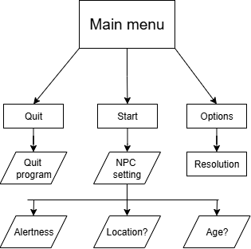
Layout of the opening menu: This simple diagram illustrates the layers of the” main menu” and where each header will lead afterwards. This will be a separate code file to maintain some elegance and readability throughout my process. My aim for this is to be quite basic / barebones to save some time and energy, but it should still be able to complete these tasks. My main worry is implementing the buttons simply as some surface level research has shown this might be quite fiddly to do.

Object oriented programming:
Class  name | Fire | People | Objects
Variables | Location (tuple)  Speed (int) | ID (int)  Age (int)  Speed (int)  Location (tuple) | Location (tuple)  Type (string)  State (String)
Methods | Spread()  Spawn()  Stop()  Changespeed() | Spawn()  Move()  Calculate_move()  Kill() | Spawn()  Destroy()

Data structures and storage
Stored data:
- Locations of people – stored in virtual board as a list (2darray all one data type)
- Locations of objects - stored in virtual board as a list (2darray all one data type)
- CharacterID – stored as a variable in the character class (int)
- Locations of fire - stored in virtual board as a list (list as can hold many different data types)
- State – used for objects for before / after they burn stored in the class as a (string)
- Flow field – stored in a separate list that matches the main virtual board (2darray for handling direction)
- Virtual board – stored in a list (array)
- User settings – Stored as a text file (txt)
- Current time – stored as a string (str)
- How many survived – Stored as an integer (int)
Storage
- I decided to store everything with a text file (.txt) because I think that it will be easiest to manipulate as I have previous experience with it.
- There will be multiple text files for things like outcome, settings, and environment.
- These will have a relatively basic structure but as they are all separate, it shouldn't pose an issue.
Algorithms and processing
BFS pseudocode:
Add start point to Queue
Mark as visited

While Queue not empty
Cur = dequeue from Queue
For each adjacent node n of v
// process node n
If n not visited
Add n to Queue
Mark n as visited

This is a simple BFS algorithm written in pseudocode that looks through nodes / points and creates a Queue that can add / remove locations. I will use this in a grid fashion and have visual representation of paths

Object class
CLASS Object()

Def init(self, location, state)
Self.location = TUPLE
Self.state = “”
Def GetLocation():
Return Location

Def GetState():
Return State

This is just a basic idea of what all my classes will copy where I can have a basic location and state and add any variables I might need down the line. As all my classes will pull from this, I only need to change it here, which helps with code efficiency and repetition.

\v
User interface _hand drawn image with annotations: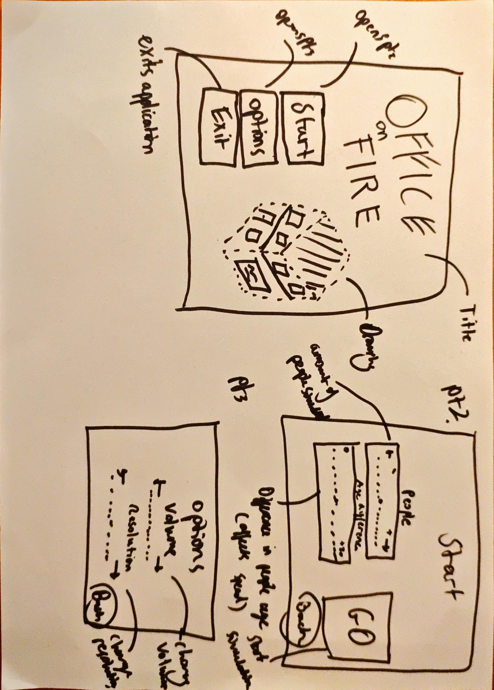

Test Strategy:

